**DHT11 temperature and humidity data analyzing in ThingSpeak WebSite:**

What is ThingSpeak?

= ThingSpeak is a Website name which is mainly used for the real time data analyzing of IOT devices. Such as temperature and humidity data analyzing in ThingSpeak.

How to Show data in ThingSpeak?

= steps:

* First log in to thingSpeak website
* Then go to my channel
* Then name that channel and create table as we need
* There is a id number and Api key (write api key, read api key) . Write api key is used for showing real time data in that website and read api key is used for read the data from ThingSpeak Website.
* Second we need to add the library of the sensor and ThingSpeak into Arduino code: #include<ThingSpeak.h>

Code:

|  |  |
| --- | --- |
| |  | | --- | | #include<ESP8266WiFi.h> #include<DHT.h> #include<ThingSpeak.h>  DHT dht(D5,DHT11);  WiFiClient client;  long ChennelId=1827422; const char WriteApikey[]="7UQJUWS8AU8WOVSM";   void setup() {   // put your setup code here, to run once: Serial.begin(9600); WiFi.begin("ICE_Innovation_Lab","beinnovative#"); while(WiFi.status()!= WL_CONNECTED) {   Serial.println("..");   delay(200); } Serial.println(); Serial.println("WiFi is connected"); Serial.println(WiFi.localIP()); dht.begin(); ThingSpeak.begin(client);  }  void loop() {   // put your main code here, to run repeatedly: float h=dht.readHumidity(); float t=dht.readTemperature(); Serial.println("Temperature"+ (String)t); Serial.println("Humidity"+ (String)h); ThingSpeak.writeField(ChennelId,1,t, WriteApikey); ThingSpeak.writeField(ChennelId,2,h, WriteApikey); delay(2000);  } | |

After Uploading this code into NodeMcu8266:

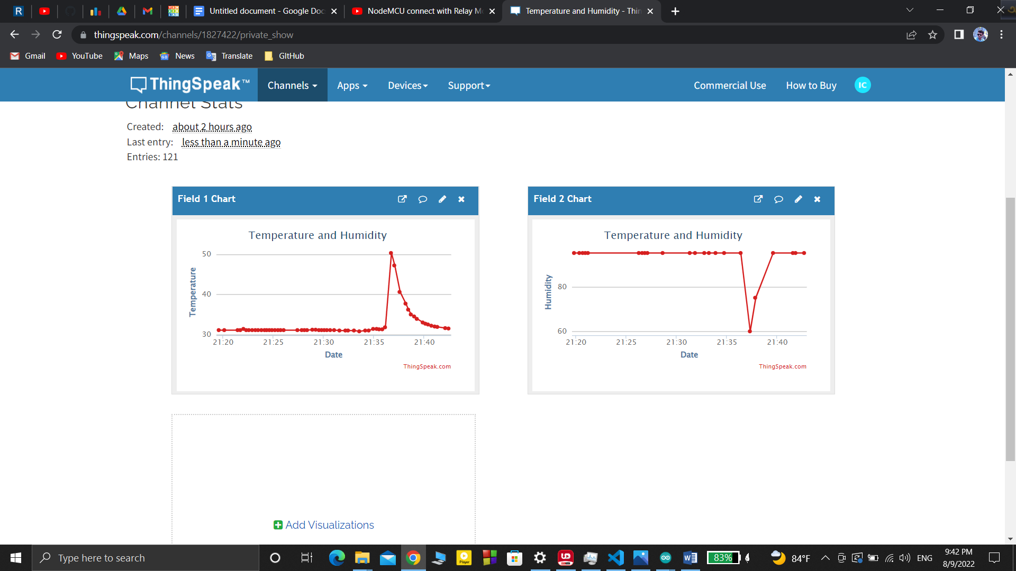

This is shoing the real time data of the temperature and humidity of DHT11